# CHAPTER FOUR

# Implementation/Results

**4.0 INTRODUCTION**

After critically analyzing the existing system and its limitations, the new system was designed with an intention of minimizing to the least extent the limitations of the old system. This section describes the system testing , design , implementation and also evaluation.

## 4.1 SYSTEM TESTING

After the software and equipment have been installed, the system should be tested. Sample data is fed into the system. The processed information is later evaluated to see whether the result is correct. If the system is perfectly alright, then the new system could be used to replace the existing system.

System (program) testing can be considered as a process of executing a program on some carefully selected or designed input data (test data) with the intention of detecting an error or errors the program might contain within a reasonable amount of time and effort. So testing comprises of three main levels namely:-

1. Unit testing.

b. integration testing.

c. validation Testing.

# 4.1.1Unit Testing;

The primary goal of unit testing is to take the smallest piece of testable software in the application, isolate it from the remainder of the code, and determine whether it behaves exactly as expected.

Each unit is tested separately before integrating them into modules to test the interface between modules. Unit testing has proven its value in that a large percentage of defects are identified during its use

# 4.1.2 Integration Testing

Integration testing, also known as integration and testing (l&T), is a software development process which program units are combined and tested as group in multiple ways. In this context, a unit is defined as the smallest testable part of an application. Integration testing can expose problems with the interfaces among program components before trouble occurs in real-world program execution.

Integration testing is a component of Extreme programming (XP), a pragmatic method of software development that takes a meticulous approach to building a product by means of continual testing and revision.

# 4.1.3 Validation Testing

At the validation level, testing focuses 'on user visible actions and user recognizable output from the system. Validation testing is said to be successful when software functions in a manner that can be reasonably expected by the customer.

Two types of validation testing:

Alpha testing is simulated or actual operational testing by potential users/customers or an independent test team at the developers site.

Alpha testing often employed for off-shelf software as a form of internal acceptance testing, before the software goes to beta testing.

Beta testing comes after alpha testing. Versions of the software, known as beta version, are released to a limited audience outside of the programming team. The software is released to the group of people so that further testing can ensure the product has few bugs or faults. Sometimes beta versions are made available to the open public to increase the feedback field to a maximal number of future users. Therefore, the system had to be tested to confirm whether it meets its requirements.

The researcher developed a prototype which was used to verify functions of the system, later to be demonstrated for the user. However, it is usual that the usability of these prototypes sometimes is not evaluated, but it was essential for the researcher to obtain the user's opinion of the prototype and this was through testing the system with the help of some users.

1. It was first tested during coding, to make sure that the codes produce the desired functionality.
2. The system administrators have clear control over the system, therefore, they do regulate user access at a given time that is to say issues regarding user authentication.
3. All links on the website work as required, information is uploaded very fast, prompting the users of the site to appreciate and view the information in time.
4. All data published on the websites becomes operational immediately, there is absolutely no lead time between an items being published and when it becomes available for public viewing.
5. The restrictions placed on users do apply and a user cannot access information he is not meant to access, in the same vein, the system administration has got absolute control over who uses the system.

# 4.1.4.Testing procedure

1. The system required installation of the WAMP server first in order to connect the website to the database, putting in mind that the Microsoft internet services software and server software APACHE is embedded in the WAMP 5.0 collection.
2. The web folder was uploaded into the www folder on the local drive.
3. The website was later accessed using any web browser.

## 4.2 Design of a new system

The conceptual design of both the website and the database was first drawn on paper later and then later transformed into a system with the help of various software tools and hardware. The entire project consists of the following modules:

### 4.2.1 Login

To launch the program, the user clicks on the icon of the program. The login box pops up for the user to enter the user name and password, it validates the user before access is granted to the user.

After the user is validated, the main form comes up. The main form is the first form that will be displayed when one logs into the system. It contains eight menus. Each of these menus contains sub-menus that collectively make up all the activities that can be done on the system.

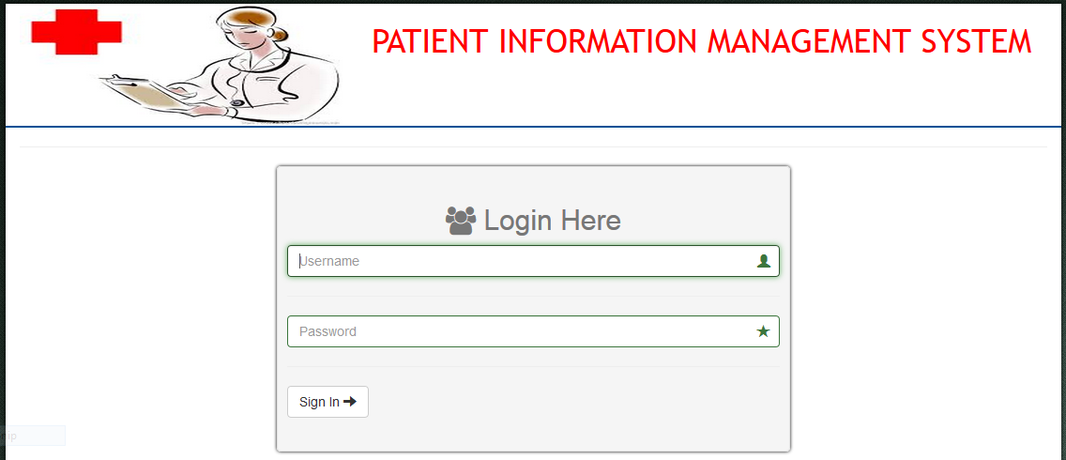

Fig 4.2.1 Login page

### 4.2.2 Patient registration

Patient registration id accomplished by entering data on the new patient registration form. The form is displayed by clicking the file menu on the main form, after which a sub menu appears and then the new patient registration sub menu is clicked. The user enters the new data. After data entry, the user clicks on the register patient button to commit the transaction. A pop up box appears showing: ‘patient successfully registered’.

The data is then stored in the database.

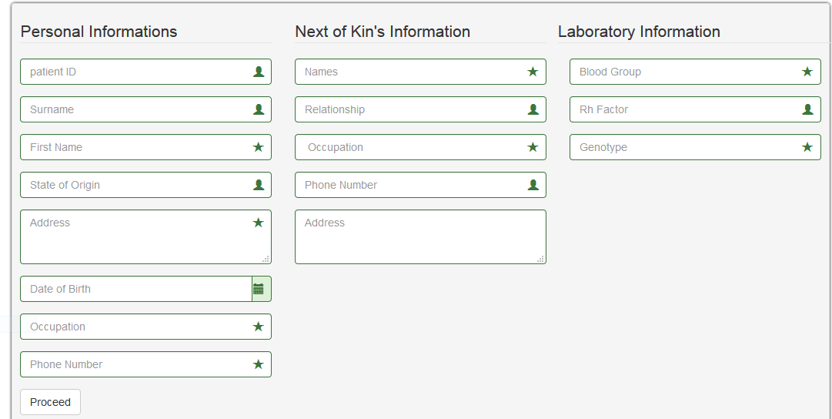

Fig 4.2.2 New Patient Registration

### 

### 4.2.3 Searching

Searching enables the user to quickly search for a patients record in the database. The search form is used to accomplish this. To launch the search form the user clicks on the search submenu of the file menu on the main form. The patient’s hospital number which is the key field for the search is entered in the text field. The submit button is clicked and the result is displayed on another form.

C:\Users\yg\Documents\internet_files\New folder\patien hist.PNG

Fig 4.2.3 Search

**Drug Allocation**

This table stores basic information about the drugs allocate to the patient and the date of allocation. Patient id and date of allocation are fields which are defined as primary keys.

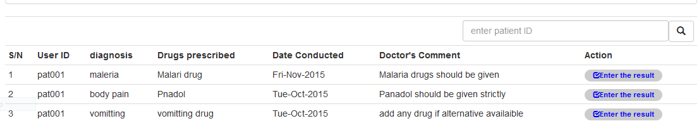

Fig 4.2.4 Drugs Allocation

### 

### 4.2.5 Test result

This table stores basic information about the tests conducted on the patient and the comments made by the laboratory technicians. Patient id and date of allocation are fields which are defined as primary keys.

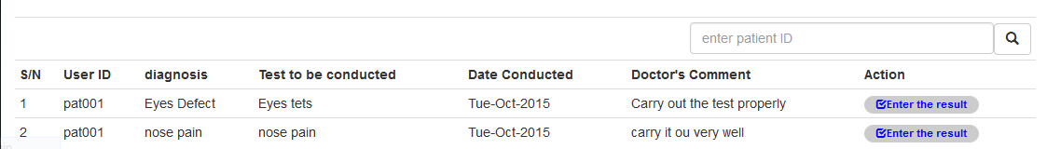

Fig 4.2.5. Test Result.

**4.3 System Implementation**

For the implementation of this project, parallel running strategy was adopted. The parallel running approach is a strategy where a new system slowly assumes the roles of the older system while both systems operate simultaneously. After a period of time, when the system is proved to be working correctly , the old system will be removed completely and users will depend solely on the new system.

## 4.3.1 Front-End Implementation

Front-end implementation (user interface) of the system is talking about the interface of the system where user would interact with the system, these user interface are created using the following languages: hyper Text make up language (HIML), cascading style sheet (CSS) and JavaScript (JS). Go to appendix and see user interfaces.

## 4.3.2 Back-End Implementation

The back-end implementation is basically talking about how database’s tables are being created

structurally using structure query language (SQL).

## 4.4 System Evaluation

System evaluation is the process of of assessing the performance of the complete system to discover how it is likely to perform and meet user needs. This also known as a performance and support phase of the system that focuses on changes associated with error, correction, adaptations required as the software environment evolves changes due to enhancement brought about by changing customer’s requirements. In general, four types of changes are encountered during the phase they are as follows:

**Correction:** This has to do with defects detected during the user of the system/software which can be corrected by the soft-ware developer. This is also known as corrective maintenance.

**Adaptation:** This involves the original changes overtime of the environments where the software runs such as operating system and the processor, for which the software was developed is likely to be changed. Thus, adaptive maintenance results in modification of software to accommodate changes that may exist with the external environment.

**Enhancement:** As system/software is used, the user will recognize additional functions or new features to increase productivity of the software, regular maintenance extends the software beyond its initial functional requirements.

**Preventive:** This has to do with the ability of the software to deteriorate due to changes that may occur to the system. But because of preventive maintenance called software reengineering, the changes that may occur to software can be easily detected and corrected.